Lesson 4 Assignment
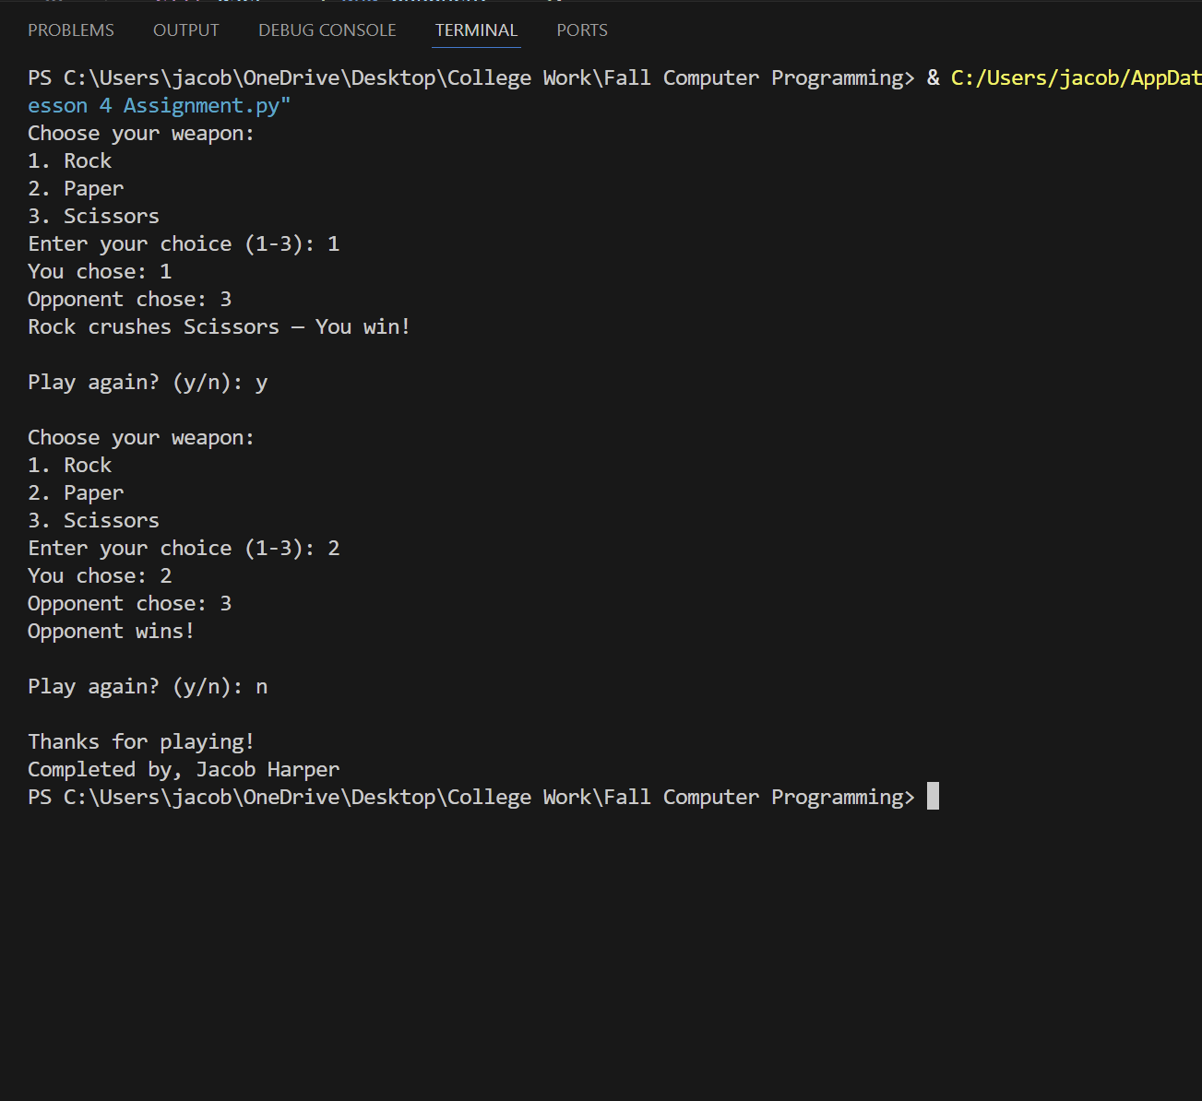
from random import randrange

def main():
continue_playing = "y"

while continue_playing == "y":
user_weapon = get_user_weapon()
opponent_weapon = get_opponent_weapon()
determine_winner(user_weapon, opponent_weapon)

print()
continue_playing = input("Play again? (y/n): ").lower()
print()

print("Thanks for playing!")

def get_user_weapon():
print("Choose your weapon:")
print("1. Rock")
print("2. Paper")
print("3. Scissors")

weapon = int(input("Enter your choice (1-3): "))
return weapon

def get_opponent_weapon():
weapon = randrange(1, 4)
return weapon

def determine_winner(user, opponent):
print("You chose:", user)
print("Opponent chose:", opponent)

if user == opponent:
print("It's a tie!")
elif user == 1 and opponent == 3:
print("Rock crushes Scissors — You win!")
elif user == 2 and opponent == 1:
print("Paper covers Rock — You win!")
elif user == 3 and opponent == 2:
print("Scissors cut Paper — You win!")
else:
print("Opponent wins!")

if __name__ == "__main__":
main()
print("Completed by, Jacob Harper")

